LLD for Traveling Package

I'm dividing the system into 3 main subcomponents, namely

1. Package Manager
2. User Manager
3. Enrollment Manager

Low level Design of the system.

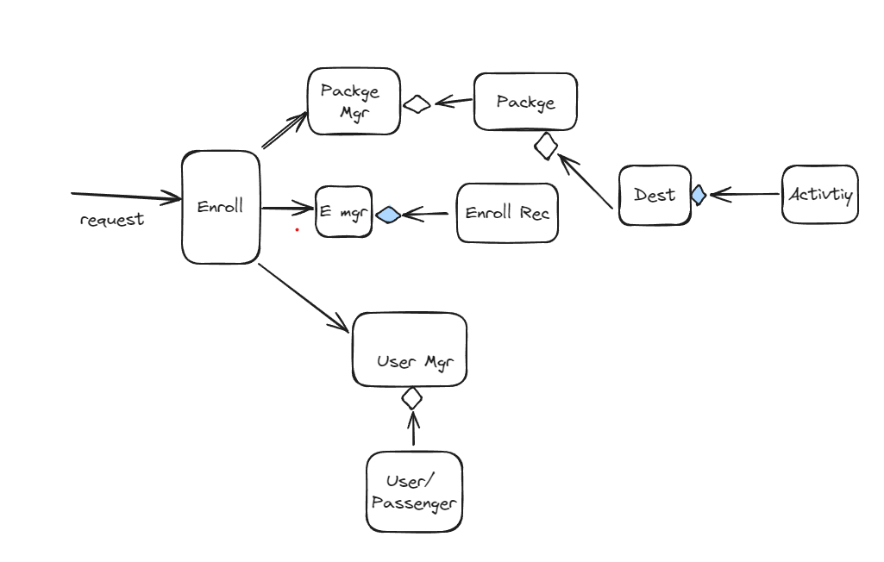

Whenever the user sends a request to enroll for a package. The request goes to enrollment services and gathers necessary info from the package manager and user manager and checks for availability and cost for the package , based on that it will enroll the passenger.

Here the package manager, user manager and Enrollment manager are singleton patterns. And I have ignored the controllers and Dtos.

Class Diagram

